Mama Corey_CMF050M__FCS
Coriolis Flowmeter Calculation Summary |  |  |  |  |  | Quote/Rev No: |  |  |  | -/-
Date: |  |  |  | ‭2023-03-30‬
Company: |  |  |  | -
Project Name: |  |  |  | -
Service: |  |  |  | -
Sensor Model Name : |  |  |  | CMF050M
Sensor Model #: |  |  |  | -
Sizing Name: |  |  |  | Mama Corey
Transmitter Model Name : |  |  |  | -
Transmitter Model #: |  |  |  | -
Transmitter Tag(s): |  |  |  | -
Wetted Material: |  |  |  | 316L
Fluid: |  |  |  | GULF COAST NATURAL GAS
Fluid State: |  |  |  | Gas
K(Flow Consistency Index) |  |  |  | -
n(Flow Behavior) |  |  |  | -
Mass Flow Accuracy (+/- % of Rate) |  |  |  | 0.2587
Pressure Drop at Operating Flow |  |  |  | 0.0981 | psig
Velocity at Operating Flow |  |  |  | 8.3073 | m/sec
 |  |  |  | Min | Operating* |  |  | Max |  |  | Design |  | Units
Flow Rate: |  |  |  | 3.0000 | 30.0000 |  |  | 40.0000 |  |  | - |  | kg/hr
Pressure: |  |  |  | - | 150.0000 |  |  | - |  |  | - |  | psig
Process Fluid Temperature: |  |  |  | - | 50.0000 |  |  | - |  |  | - |  | F
Ambient Temperature: |  |  |  | - | 68.0000 |  |  | - |  |  | - |  | F
Density: |  |  |  | - | 0.5192 |  |  | - |  |  | 0.0000 |  | lb/ft3
Viscosity: |  |  |  | - | 0.0103 |  |  | - |  |  | - |  | cP
Gas Only | Base Reference Temperature: |  | F | 60.0000
Gas Only | Base Reference Pressure: |  | psia | 14.6960
Gas Only | Base Reference Density: |  | lb/ft3 | 0.0440
Process Connection: |  |  |  | -
Process Connection Pressure Rating: |  |  |  | -
@Temperature: |  |  |  | 50.0000 F
Flow Rate | kg/hr | Mass Flow Accuracy (+/- % of Rate) |  | Pressure Drop* | psig |  | Velocity at Operating Flow |  | m/sec |  |  | Re
40.0000 |  | 00.2500 |  | 0.1656 |  |  | 11.0764 |  |  |  |  | 78611.2858
36.3000 |  | 00.2500 |  | 0.1388 |  |  | 10.0518 |  |  |  |  | 71339.7419
32.6000 |  | 00.2500 |  | 0.1141 |  |  | 9.0273 |  |  |  |  | 64068.1979
28.9000 |  | 0.2686 |  | 0.0916 |  |  | 8.0027 |  |  |  |  | 56796.6540
25.2000 |  | 0.3080 |  | 0.0714 |  |  | 6.9781 |  |  |  |  | 49525.1101
21.5000 |  | 0.3610 |  | 0.0534 |  |  | 5.9536 |  |  |  |  | 42253.5661
17.8000 |  | 0.4361 |  | 0.0379 |  |  | 4.9290 |  |  |  |  | 34982.0222
14.1000 |  | 0.5505 |  | 0.0249 |  |  | 3.9044 |  |  |  |  | 27710.4782
10.4000 |  | 0.7463 |  | 0.0145 |  |  | 2.8799 |  |  |  |  | 20438.9343
6.7000 |  | 1.1585 |  | 0.0069 |  |  | 1.8553 |  |  |  |  | 13167.3904
3.0000 |  | 2.5873 |  | 0.0019 |  |  | 0.8307 |  |  |  |  | 5895.8464
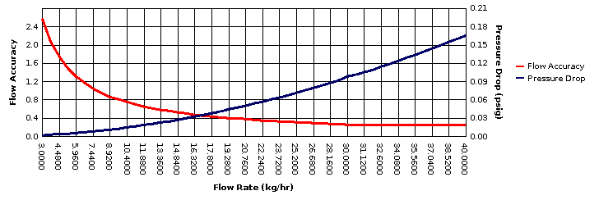
* All pressure drop and velocity results are based on the process conditions (except flow rate) that are entered in the Operating column.

